

Sri Lanka Institute of Information Technology

Destination Management System
Software Requirement Specification

Information Technology Project 2009

Project ID: ITP/09/B/G2

Submitted by:

1. DIT/08/C1/0235 – (V.Thivaharan)
2. DIT/08/C1/0143 – (K.Kasthuri)
3. DIT/08/C1/0195 – (R.Dharshitha)
4. DIT/08/M3/1604 – (Y.Tharangini)
5. DCN/08/C3/0585 – (S.Sinthana)
6. DIT/08/C1/0215 – (P.Premje)
7. DIT/08/C1/0182 – (S.Mayoorika)
8. DIT/08/C1/0226 – (G.B.Weerasinghe)
9. DIT/08/C1/0108 – (S.Rajprasanth)

Submitted to:

…………………………..

Miss. Endaragalla Piuma

……………………………

Date of submission

Table of Contents
Table of Contents 1
Revision History 2
1. Introduction 3
1.1 Purpose 3
1.2 Document Conventions 3
1.3 Intended Audience and Reading Suggestions 4
1.4 Product Scope 5
1.5 References 6
2. Overall Description 7
2.1 Product Perspective 7
2.2 Product Functions 8
2.3 User Classes and Characteristics 9
2.4 Operating Environment 10
2.5 Design and Implementation Constraints 11
2.6 Project Documentation 11
2.7 User Documentation 12
2.8 Assumptions and Dependencies 12
3. External Interface Requirements 13
3.1 User Interfaces 13
3.2 Hardware Interfaces 24
3.3 Software Interfaces 24
3.4 Communications Interfaces 24
4. System Features 25
4.1 Functional Requirments 25
4.2 Usecase Diagram 30
4.3 Usecase scenarios 34
4.4 Activity Diagram 41
5. Other Nonfunctional Requirements 43
5.1 Performance Requirements 43
5.2 Safety Requirements 43
5.3 Security Requirements 43
5.4 Software Quality Attributes 44
5.4.1 Usability 44
5.4.2 Maintainability 44
5.4.3 Robustness 44
5.4.4 Availability/Reliability 45 5.5 Business Rules 45
6. Other Requirements 46
6.1 Appendix A: Glossary 46
6.2 Appendix B: Class Diagram 47
6.3 Appendix C: Flow Of User Interface 48

List of figures
Figure1 :Components of the system 7
Figure2 :Product functions 9
Figure3 :Login interface 13
Figure4 :Create new account interface 14
Figure5 :Remove internal user interface 15
Figure6 :Reset profile interface 16
Figure7 :Reset own profile interface 17
Figure8 :Registration form interface 18
Figure9 :Update charge changes form interface 19
Figure10 :update upcomming events interface 20
Figure11 :Handle the customer questionnaries interface 21
Figure12 :Marketing officer’s profile reset form interface 22
Figure13 :Online payment form interface 23
Figure14 :Usecase for internal users 30
Figure15 :Usecase for clients(tourist) 31
Figure16 : Usecase for administrator 32
Figure17 : Usecase for accountant 32
Figure18 : Usecase for marketing officer 33
Figure19 : Activity diagram for tour registration 41
Figure20 : Activity diagram for internal user’s activities 42
Figure21 : Class diagram for destination management system 47
Figure22 : Flow of user interface 48

Revision History
Name | Date | Reason For Changes | Version

Introduction

1.1 Purpose
Destination Management System (DMS) for Walkers Tours Limited (WTL) is intended to manage client (Tourist) information such as registration details, tour details (Places, Hotels, Food and Accommodation) and payment details in an effective and efficient way within the company. By reading this document the users of this system would be able to get a clear idea of the problem to be solved. The users of this system will be able to identify the different features and functions of the system.
This document is meant to describe all the requirements of DMS, so as to serve as a guide to the development team (DIT 2nd Year group ITP/09/B/G2) on one hand and a software validation document for the prospective client on the other.

Document Conventions
This document will have a standard format with font “Times New Roman” , font size 18 and bold for the main topics, font size 14 and bold for the sub topics and all remain will be in font size 12 without bold. The main topics and the sub topics will be numbered as follows. That means if the main topic has the number 1 then the sub topic coming under that will have the number 1.1 and so on. The names of the interfaces and forms are in italic. The main topics of this document are introduction, description, external interface requirements, system features and non-functional requirements.
Priorities are given for the higher level requirements. Those higher level requirements stated using bold style in use case scenarios.

Intended Audience and Reading Suggestions

This document is basically intended for system developers and system users of the proposed system.
This section of the document provides an introduction to the entire SRS document. Therefore this section is suitable for both parties to start reading the document.
This document had written in simple English.

Section 2: provides overall description of the system that will be produced
• Product Perspective
• Product Activity
• User Characteristics
• General Constraints
• Assumptions and Dependencies

Section 3: Include detail description of the specific requirements of the proposed system
• Functional requirements –This include descriptions of use cases
• External interface requirements
• Performance requirements
• Design Constraints
• Attributes
Section 4: Appendices
- Interfaces Appendix A-Glossary
- Appendix B-Use case diagram
- Appendix C-System Interfaces
Section 3 contains more technical details so it will be difficult for system user to read and understand. They can get the help of the glossary in appendix A to read that section.

Product Scope
We describe the functions with in the scope of the proposed system.
This system supposed to manage client (Tourist) information such as registration details, tour details (Places, Hotels, Food and Accommodation) and payment details.

Benefits of this DMS
- Improved management information
- Faster processing of staffs & services details
- More accurate tourist details and information
- The new system is going to radically change the way the Walkers Tours administration, services.

Objectives of this DMS
    - Ease and reduce the work load of the end users
    - Increase the reliability and efficiency of the work process
    - Provide more capabilities in order to fulfill user requirements up to the maximum level
    - Increase user friendliness towards the system
    - Interoperability of the system

Goals of our project
- Give an immediate response.
- Maintain documents, various action which involved with DMS.

References
[1] Hughes, B. & Cotterell, M.; 2001; Software Project Management; 2nd Edition; New Delhi: Tata McGraw-Hill Publishing Company Limited

[2] Louis, J.Goodman; 1996/ 2001; Project Planning & Management; First Ed; New Delhi; CBS Publishers & Distributors.

[3] Effective Project Management for Web Geeks [online] (updated13th June), p.01-02, Available at: - http://www.sitepoint.com/article/project-management-web-geeks [accessed 8th July 2008]

[4] Ritchie M, 2002 Background, Objectives, Benefits, Scope, Deliverables, Assumptions and Constraints, Estimates. Cost project proposal document of, Corporate Application Technology – Configuration Management [online] (updated 8th Jan), Document. Available at: -http://www.projects.ed.ac.uk/planning/Corporate_IT/2002-03Planning/mis/CorpInf/SoftwareConfigurationManagement.doc [accessed 6th July 2008]

[5] Data Management Subsystem Database Design and Database Schema Specifications for the ECS project, March 199, EOSDIS Core System Project.(pgs 20-45)

[6]Software Requirement Specification Template (Updated 21/09/2008) Available at: http://www. .processimpact.com (Accessed 10/10/2008)

2. Overall Description

Product Perspective
This product is not a follow-on member of a product family, also a replacement for certain existing systems. So this is a self-contained product creating for WTL.

Destination Management System
Client Registration
Payment Handling
Update upcoming details
Maintaining Tourist
Details

Provide Managerial Reports
Mileage Calculation

Figure 1: Components of the system

Product Functions
System should support the following use cases:
Class of use cases | Use Cases | Description of use cases
Use cases related to  System authorization | Login | Use to login to the system
Use cases related to  System authorization | Change Profile | Change passwords and usernames
Use cases related to  System authorization | Log Out | Logout from the system
Use cases related to  System authorization | Create new user Accounts | For new internal users
Use cases related to  Client registration | Registration | Register new clients
Use cases related to  Client registration | Edit client Details | Change existing data
Use cases related to  Client registration | Delete client Details | Remove registered data
Use cases related to  payments | Make Payment | Enter payment details
Use cases related to  payments | Refund | Enter cancellation details
Use cases related to  Calculation | Calculate Mileage charges according to places selection. | Enter Place details
Use cases related to  Calculation | Calculate Package charges | Enter package details
Use cases related to  Calculation | Calculate Hotel charges | Enter Hotel details
 | Calculate foods charges | Enter meal type
 | Calculate Guide charges | Enter Guide details
 | Calculate vehicles charges | Enter vehicles details
Use cases related to  Update upcoming events | Calculate Service Charges | Enter service details
Use cases related to  Update upcoming events | Calculate Day charges | Enter no of days going to stay
Use cases related to  Update upcoming events | Mail upcoming events | Enter upcoming details
Use cases related to mail reminders | Mail reminders to registered tourist | Enter tourist details
Use cases related to  Cancelling registration | Cancel registered Details | Enter cancellation details
Use cases related to  Produce reports | Produce reports details | Enter management functions

Figure 2: product function

2.3 User Classes and Characteristics

Users of the proposed system are not in same level in technical knowledge ^{[2]}. Also they are in various positions in technical expertise, security or privilege levels, and experience.
This software product is mainly designed and implemented to make help on destination managing process by an Administrating level system user. This administrative level user is the main frequent user of the system which is described in this SRS. Many other actors are involved in this process of interacting with the system, and it is required that everybody who would use this system posses some level of computer literacy so that he or she could interact with the interfaces.
Here we describe those users according their characteristics.

Administrator- User has privileges to access entire system. He/She is the owner of this system. He/She is well experienced with system activities. He/She has privileges to add new users to the system, view client comments and change some system features. He/She is technically expertise in web based systems and network administration. Also He/She has good technical knowledge regarding computerized systems.
Marketing Officer - Again another frequent user of the system. User has privileges to internal activities such as update new changes in prices, mail upcoming events. Also view client feedbacks. He/She is well educated person and has experience to involve with his own system activities.
Accountant - He/ She has privileges only to view managerial reports. Privilege level is low compare to the other main users. Also He/She has good knowledge regarding business administration.
Clients - Low level of privileges for this user as well. Less important to satisfy the requirements of this user compare with the other requirements. He/She has knowledge regarding web browsing.

Operating Environment
The system specified in this SRS has a connected network to insert and retrieve information at any moment the information is required ^{[1]}. The project will be web based and standalone application. Required memory of the user PC is 1GB RAM
As this product is developed using ASP.NET, MS SQL - 2005 and Microsoft office package, Photoshop-7, Flash-8 these software must help maintain the deployed system. The software and the developed system must run in the windows environment and this system is the first version of its being deployed.
In order to fulfill some functions of this proposed system, it will need a printer and a scanner as hardware devices.
Persons who will be having direct involvement with the system should have a basic computer literacy to operate and work with the system.

Design and Implementation Constraints
When designing and implementing this system there will be several constraints that need to be applied. This product must operate on Windows operating system. When implementing this system there are some hardware requirements that should be fulfilled. It can run on as many hardware configurations. The minimum memory requirement is 1GB of RAM. We will use ASP.NET, HTML and Java Scripting languages to implement this. Both Photoshop and flash used to design GUI, and the interfaces designed using visual studio 2005. The database will be implemented by using MS-SQL.

There will also be some other constrains such as each individual trying to log into the system should have a user name and login. There will also be different access levels, such as the administrative officer having more access rights when compared to other users.

Project Documentation
On completion of this project, the following documents ^{[6]} can be made available to the users, along with the final DMS that is to be implemented.
- Abstract - Brief description about DMS
- Introduction – Introduce DMS by describing what we done and its important.
- Background - Brief description about hardware and software requirements for DMS
- Analysis and Design- The designing modules of our DMS are shown in this part from the requirement gathering.
- User Interface- All the interfaces of DMS are shown here with the description of how to deal with it.
- Conclusion- The short description about the DMS and all the effects put in to the development of the system are described here.

User Documentation
We supposed to deliver a user manual and software documentation as user documentation components along with the software.

Soft ware documentation:
Clear and complete documentation of the software system will provide in order to future reference ^{[3]}. Those documents will be need in future maintenance and/or modification of the system.

Users’ Manual:
A step by step user guide will be demonstrating when user needs the help. It will explain all the functionalities of the web based system.

Assumptions and Dependencies
When designing this system there were some assumptions and dependencies ^{[4]} observed. They are listed below.
- Company always has to know about available hotels, guides, vehicles.
- If charges will exceed to the collected bill amount, it will collect manually at particular places.
- If client want to cancel the reservation, they want to inform before two weeks. If not payments not refund.
- Company always has to know about the events that are planned to be held in Sri Lanka. (Nuwara-Eliya flower festival, Dalatha pherhara, etc).
- Company always has to know about Sri Lankan situation, weather condition.
- WTL using only brand new vehicles and all those vehicles which have a full insurance.
- We assume that the mileage for places is never changed or different. But charges can be changes according to the situations.

3. External Interface Requirements

3.1 User Interfaces
- Internal users of the system should enter their password and username when they are going to access the system. Administrator, Accountant and Marketing officer are going to use below form.

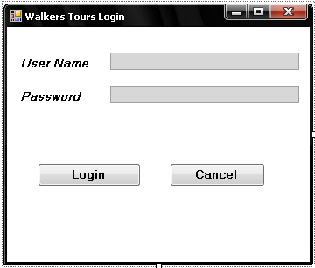
Figure 3: login interface

This interface is the same for all users and when the user has logged in successfully, window gets expanded automatically.

- Administrator can create the new account for internal users using below form

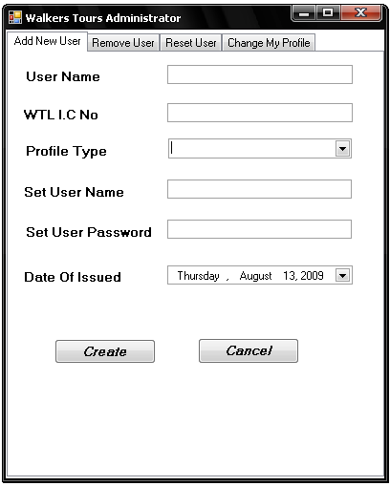
Figure 4: create new account interface

Account type includes Administator or Accountant or Marketing officer.

- Administrator can remove or block the internal user accounts using below form.

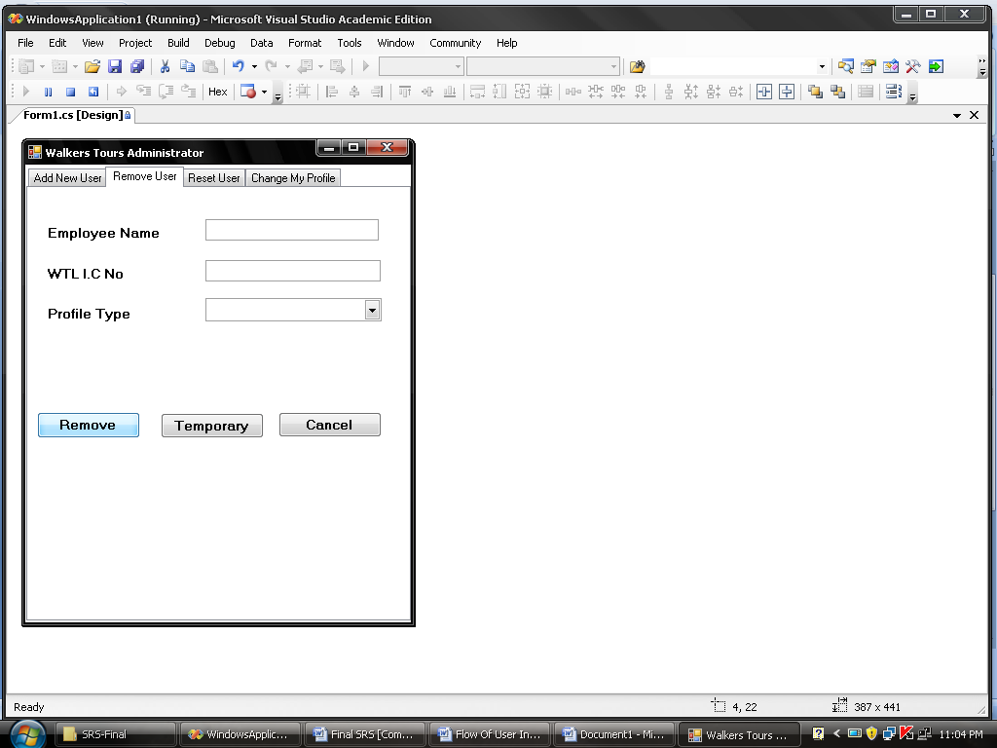

Figure 5: Remove internal user interface

- Administrator can reset the accounts using below form.
Administrator used this form when cancel the internal user temporary block or change the account type.

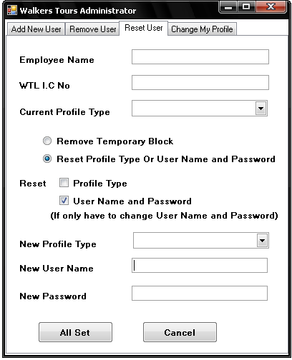
Figure 6: Reset profile interface
- Administrator can reset own account using below form.

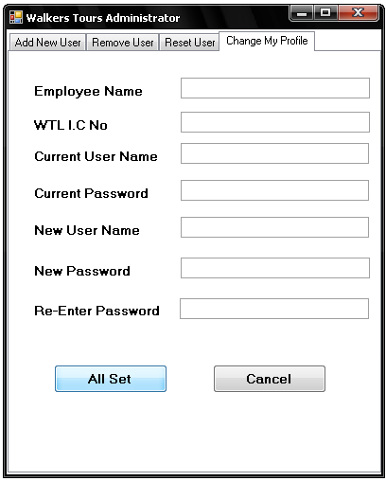

Figure 7: Reset own profile interface
- After view our website clients (Tourist) can register for tour using below registration form.

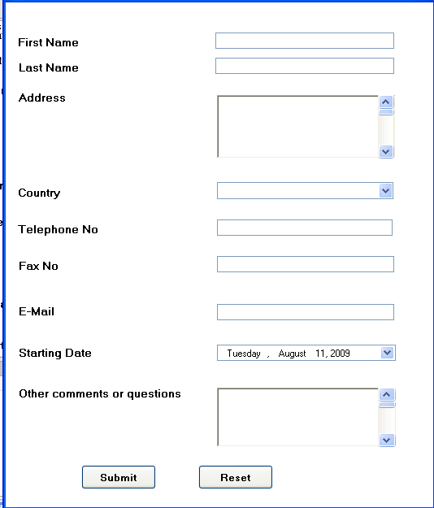
Figure 8: Registration form interface

- Marketing officer can change the service charges using below form.

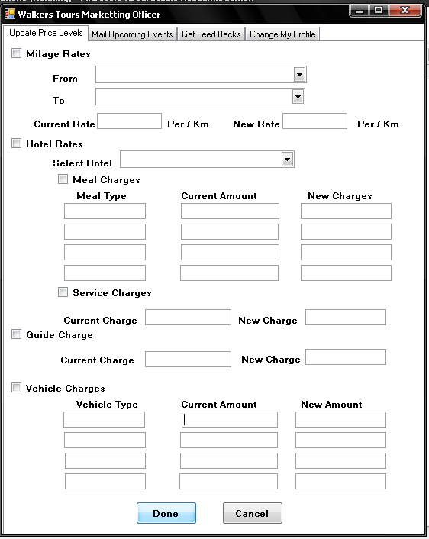

Figure 9: update charge changes form interface

- Marketing officer can update the upcoming events using below form.

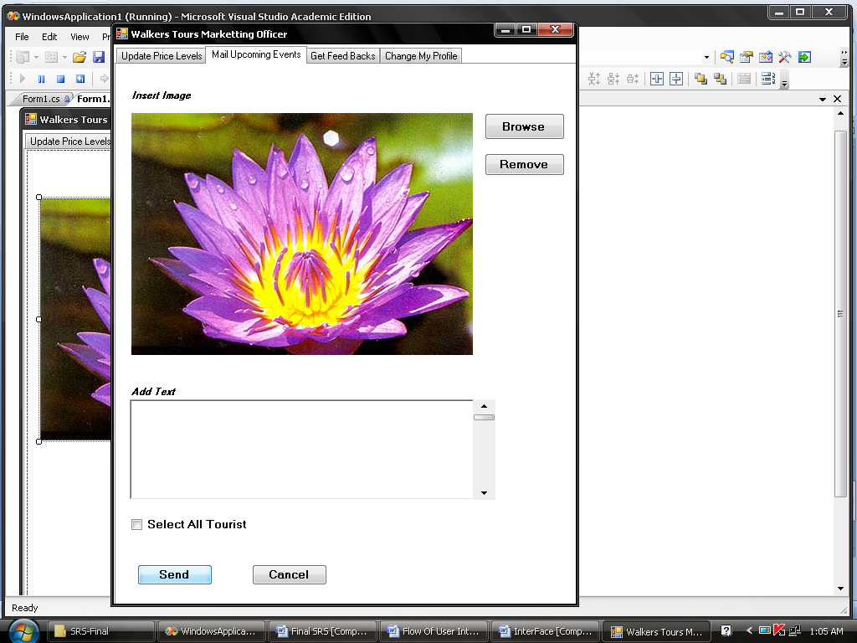

Figure 10: update upcoming events interface

- Marketing officer can view the client’s feedback using below interface.
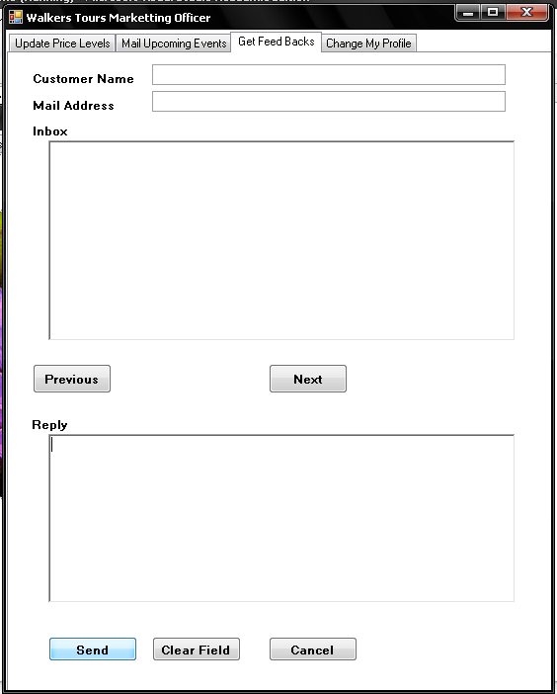

Figure 11: handle the customer questionnaires interface

- Marketing officer can reset own profile using below form

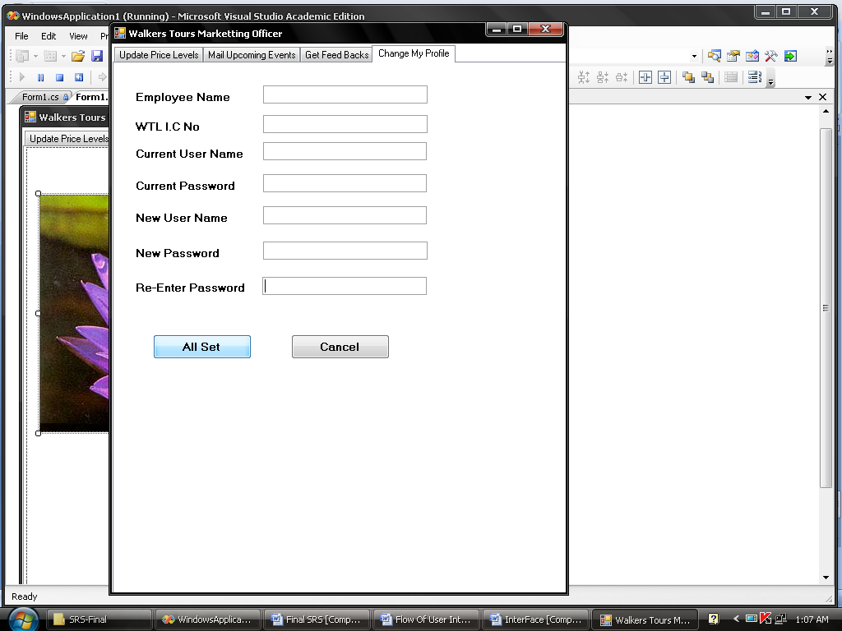

Figure 12: marketing officer’s profile reset form interface

- clients can pay online using below form
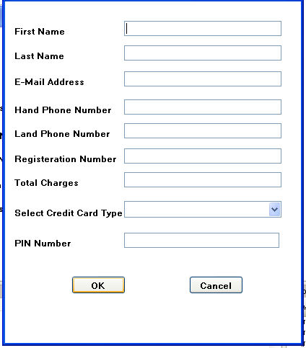

Figure 13: online payment form interface

3.2 Hardware Interfaces
WTL main database and the main server machine will be the core hardware interfaces in this scenario because the proposed system will work as a web based system and standalone application this must be install in the main server machine.
Also this needs a printer to print several documents and a scanner to scan a photograph when the system is going to mail upcoming events.

3.3 Software Interfaces
System supposed to interface with the Windows (95, 2000 and XP). System should interface with server software (MYSQL as database server and WTL web server).

3.4 Communications Interfaces
We need E-mail, web browser and several communication protocols (SMTP, HTTP) as communication interfaces to implement the system.

There are some basic requirements and they are mentioned below.
- Two or more computers with network cards (Ethernet or wireless) installed in all of them.
- A cable modem or DSL modem (usually provided by your Internet Service Provider)
- An active working high-speed Cable or DSL Internet connection (dial-up is not high-speed and is not covered in this setup)
- A router which has at least three ports to network devices.

System Features
  - Functional Requirements

We describe the functional requirements of the proposed system by giving various use cases

F1: Select a tour.
Input: Packages vise tour or non-package vise tour.
Output: Tour details according to the selection.
Process: provide the details about available tour.
Description: packages include a set of places those are available for visit,
Non-package means not a set of places; tourist can select the places according to their own wished.

F2: Calculate the package vise tour charges.
Input: Tour type.
Output: Amount for tour.
Process: Calculate the charges according to their selection.
Description: packages include a set of places those are available for visit.

F3: Calculate the Non-package vise tour charges.
Input: selected places.
Output: Amount for tour.
Process: Calculate the charges according to their selected places mileage.
Description: Non-package means not a set of places; tourist can select the places according to their own wished.

F4: Calculate the hotel charges.
Input: selected hotels and no of days.
Output: Amount for hotels.
Process: Calculate the charges according to their selected hotels and days.
Description: Hotel types such as TajSamuitthera, Heltan.

F5: Calculate the food charges.
Input: selected food type and no of persons.
Output: Amount for foods.
Process: Calculate the charges according to their selected food types and no of person.
Description: Food types include full meal or half meal.

F6: Calculate the vehicle charges.
Input: selected vehicle type, no of days and no of persons.
Output: Amount for vehicle.
Process: Calculate the charges according to their selected vehicle types, no of days and no of person.
Description: vehicle types include car or van or bus.

F7: Calculate the additional service charges.
Input: selected additional services.
Output: Amount for additional services.
Process: Calculate the charges according to their selected additional charges.
Description: Additional services include guide service.

F8: Preparing Total Bill
Input: the entire selected items amount.
Output: Total Bill
Process: Calculate Total Amount According their selected items.
Description: total bill include total amount of their expenditure like hotel charge, food charge, vehicle charge, and other additional charges.

F9: Client Registration.
Input: Tourist details.
Output: Registered details.
Process: store the tourist details.
Description: Tourist details include tourist name, country, Telephone No, Address, Email Address, etc.

F10: Payment
Input: Credit card no, Name
Output: Message.
Process: validate the credit no and the amount
Description: credit card has a unique PIN number.

F11: Canceling the Tour
Input: Information about Tourist details and cancelling details.
Output: canceled report.
Process: Store only tourist mail Address and remove other all details of tourist
Description: information of tourist personnel details like name, address, and telephone no, etc.

F12: Refund
Input: Paid amount and other details of tourist who want cancel the tour.
Output: Message about credit information.
Process: Credit some amount from their payment
Description: Other details of cancelled tourist include their name, address, paid amount, etc.

F13: Sending Reminder Message
Input: Tourist Email Address
Output: Reminder Message
Process: Prepare the reminder message of their reservation and Send Reminder Message
Description: reminder message include that data of their tour, etc.

F14: Sending emails about upcoming events
Input: Tourist Information and Email Address
Output: Email about upcoming events.
Process: update the upcoming events and send Mails.
Description: upcoming events include Nuwara-Eliya flower festival, Dalatha pherhara, etc.

F15: create the new internal user accounts.
Input: internal user information
Output: username and password.
Process: create the new account for new internal user.
Description: user account means profile for her/his internal work and internal user information include internal user position such as administrator or accountant or marketing officer.
F16: Block or remove the internal user accounts.
Input: internal user information
Output: cancel message.
Process: block or temporary block the account for new internal user.
Description: user account means profile for her/his internal work and internal user information include internal user position such as administrator or accountant or marketing officer.

F17: Reset the internal user accounts.
Input: internal user information, old username and password.
Output: New username and password.
Process: Reset the account for new internal user.
Description: user account means profile for her/his internal work and internal user information include internal user position such as administrator or accountant or marketing officer.

F18: update the new changes.
Input: old details.
Output: new changes details.
Process: update the new changes according to the changes.
Description: new changes include charges changes, etc.

F19: update the upcoming events.
Input: upcoming events details.
Output: changes with upcoming events.
Process: update the new changes according to the changes.
Description: upcoming events include Nuwara-Eliya flower festival, Dalatha pherhara, etc.

F20: provide the managerial reports.
Input: Account details.
Output: managerial reports.
Process: prepare the managerial reports.
Description: managerial reports include annual report, profit graph.

  - Use case diagram

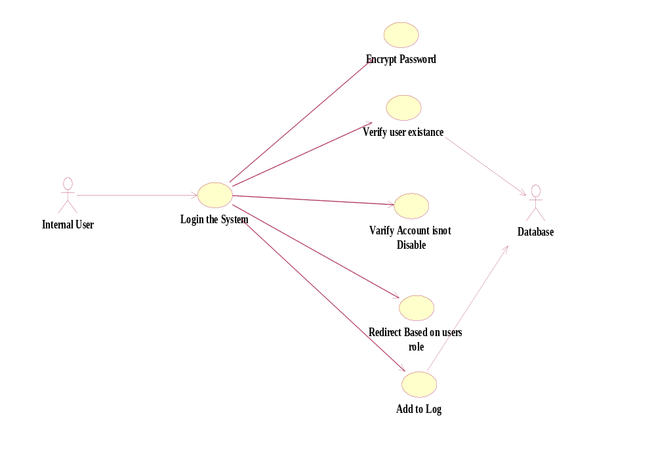

Figure14: Use case for internal users
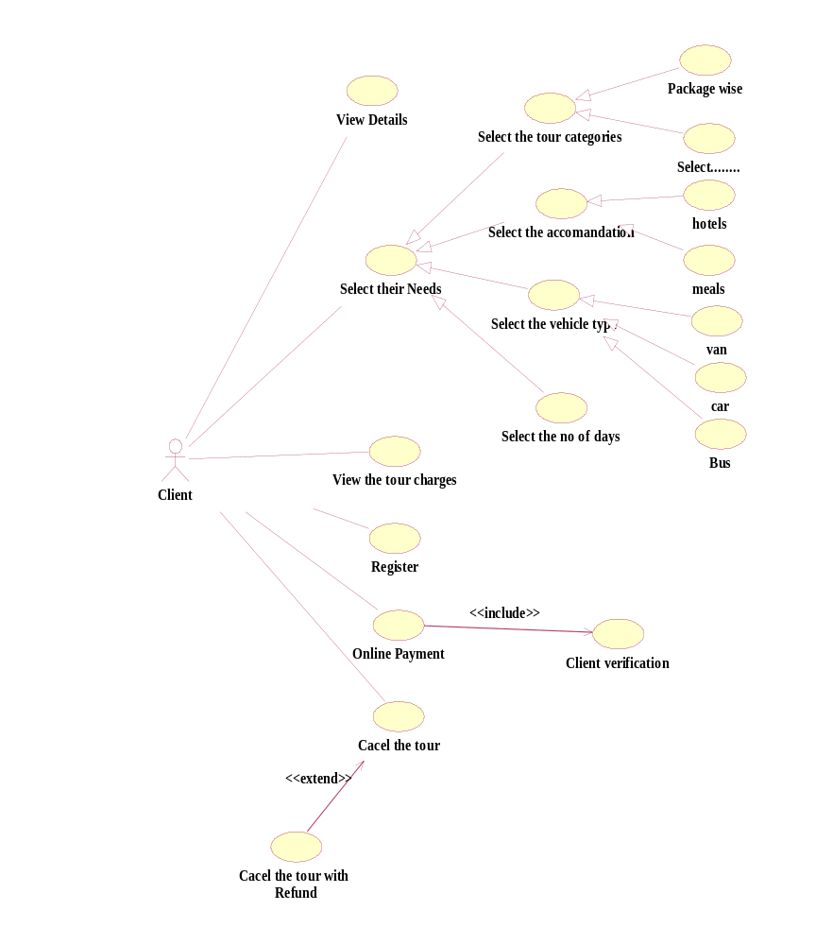
figure15: Use case for clients (Tourist)
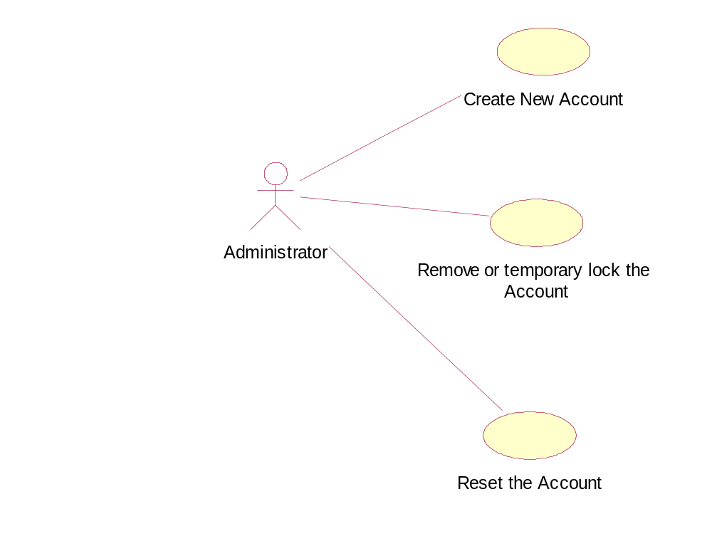
figure16: Use case for administrator

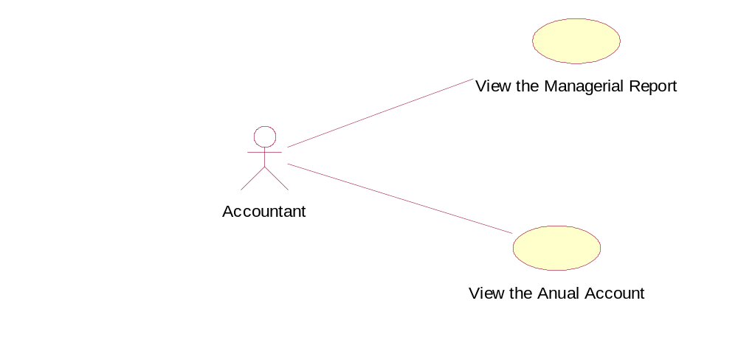
figure17: Use case for Accountant

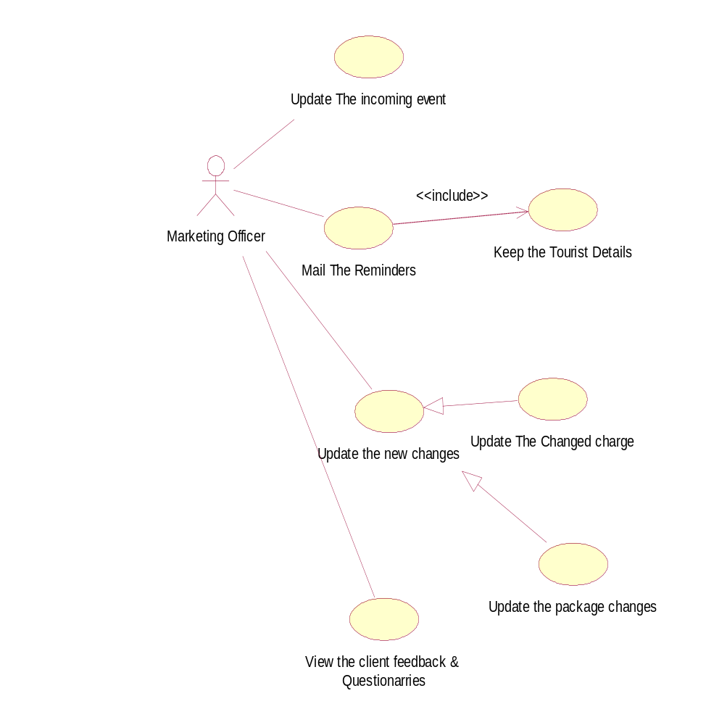

figure18: Use case for marketing officer

  - Use case scenarios

Use Case 1: Login
Primary Actors: Administrator, Accountant, Marketing officer.

Pre-Condit ion: System should be up

Main Scenario:
- Use case starts when an actor needs to login to the system
- User prompted for User Name and Pass Word
- User enter his own User Name and Password
- System does the authentication
- Display the main screen specific for that user.

Extensions:
3. (a) Username or password is not entered
- (a)1. Prompt the user Username or password is not entered.
- (a)1 . Allow him to enter user name or password.
4. (a) User Name or Pass Word is not valid
- (a) 1. Prompt the user invalid User name or password
- (a) 1. Allow user to re-enter invalid username or password. Give him 3 times.

Post Condition: User’s main screen should display

Use Case 2: Tour selection

This use case will provide the capability of select tour.

Primary Actor: Client (Tourist)

Pre-Condition: System should be up

Main Scenario:
- System displays a screen which contains the Tour category (with initially blank text boxes or selectable option buttons).
- Select the tour category.
- Select the Hotels.
- Select the food type.
- Select the vehicle type.
- Select the additional services.
- System prompts the total amounts and selected details.
- System is updated with new details.
- End Use Case

Extensions:
- (a) Total amount exceed reselect the services.

Post- Condition: Database should be updated

Use Case 3: Registration
This use case will provide the capability of registering for tour.
Primary Actor: Client (Tourist)
Pre-Condition: System should be up
Main Scenario:
- System display a screen which contains following fields (with initially blank text boxes or selectable option buttons) as required by the user
Personal Details: Client Name
Nationality
Date of Birth
Sex
Passport number
Country
Contact Details: Permanent Address
Telephone Number
Email Address
Tour Details: Starting date of tour
Payment type
Payment date
2. System is updated with new details.
3. End Use Case
Extensions:
1.(a) Client passport number or Payment date or Payment type or amount is not entered
1. (a) 1. Prompt the user enter passport number or Payment date or
Payment -type.
1. (b) 1.Ivalid passport number
1. (b) 2. Prompt the user he has entered an invalid passport number.
Post- Condition: Database should be updated

Use Case3: Make Payment

This use case will help the client to handle the payments for a tour.
Primary Actor: Client (Tourist)

Pre-Condition: Client should be a registered student

Main Scenario:
- Client initiates the make payment command.
- System prompted a form for following details
Registered Number
Payment Date
Payment Type (Full Payment/Installment)
Amount
Name
Credit Card type
PIN number
- Enter and save details
- System is updated with new details.
- End use case

Extensions:
3. (a) Registered number or Payment date or any field is not Entered
3. (a) 1. Prompt the user enter particular field.

3. (b) Invalid PIN number
3. (b) 1. Prompt the user he has entered an invalid PIN number.

3. (c) Account balance is not enough
3. (c) 1. Prompt the user that account balance is not enough.

Post- Condition: Database should be updated

Use Case 4: Sending Reminders.
This use case needs to send e-mails for the clients reminding about their tour.
Primary Actor: System
Pre-Condition: System is up and running
Main Scenario:
- System is automatically initiates this use case.
- Get the list of clients who need to remind for the tour (before one weeks to tour)
- Send e-mails to them informing that the tour details.
- End Use Case
Extensions:
2. (a) Cancel the registration who register for tour.
2. (a) 1. Prompt a message telling No reminds needed for this moment.
Post- Condition: All the relevant clients receive an e-mail

Use Case5: update upcoming events
This use case allows marketing officer to update upcoming events.
Primary Actor: Marketing officer
Pre Condition: User logged in
Main Scenario:
    - User initiates the Give command.
    - User can update the upcoming events.
    - System is updated with new events.

Use Case 6: Create new account

This use case allow administrator to create new account for new internal users.

Primary Actor: Administrator.

Pre Condition: user logged in

Main Scenario:
1. User initiates the create account command
2. User is prompted for username, WTL I.C no, account type, set username, set password.
3. User gives the username, WTL I.C no, account type, set username, set password.
4. System does authentication
5. New account is registered with the system

Extensions:
4 (a). Authentication Fails
4 (a)1. Prompt the user that he typed the wrong WTL I.C
4 (a)2. Allow him to re-enter the WTL I.C

Use Case 7: Change Profile
This use case allow user to change the password that is using currently.
Primary Actor: Administrator, Accountant, Marketing officer.
Pre Condition: user logged in
Main Scenario:
1. User initiates the change profile command
2. User is prompted for old password, new password and confirm new password
3. User gives the old password and new passwords and confirms the new password
4. System does authentication
5. New password is registered with the system
Extensions:
4 (a). Authentication Fails
4 (a)1. Prompt the user that he typed the wrong password
4 (a)2. Allow him to re-enter the password. Give him 3 chances.
4 (b). New password and confirm password do not match.
4 (b)1. Allow him to re-enter the attributes. Give him 3chances.

Use Case 6: Log Out
This use case allows users to log out from the system.
Primary Actor: Administrator, Accountant, Marketing officer
Pre Condition: user logged in
Main Scenario:
- User initiates the Log Out command
- User is prompted for confirmation.
- User Log Out.
Extensions:
2. (a) cancel the confirmation
2. (a) 1. User will not Log Out

4.4 Activity diagram
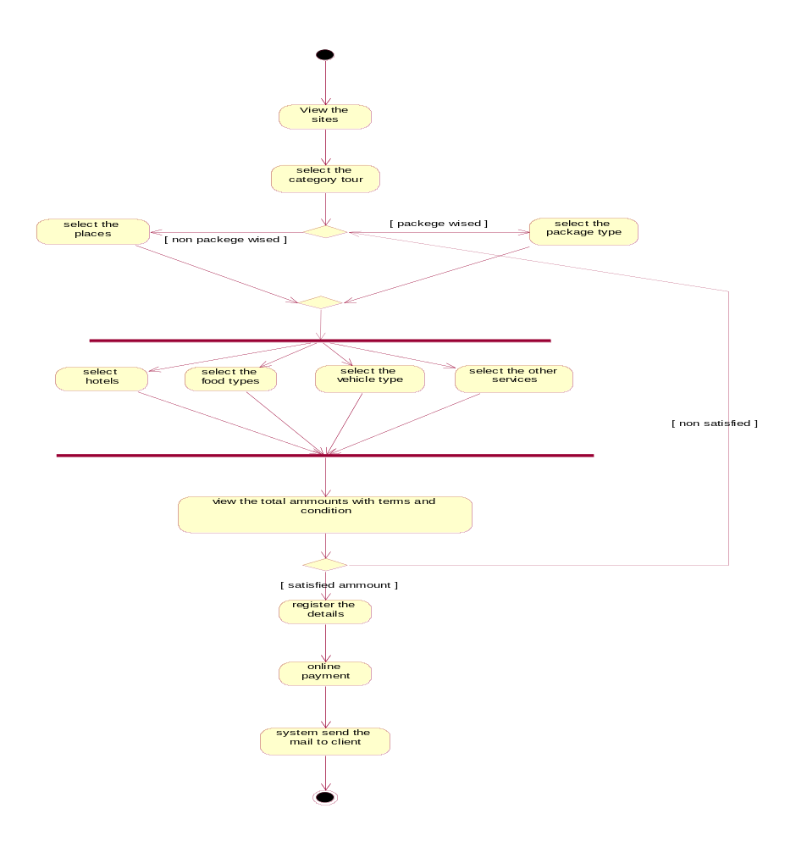
figure19: Activity diagram for tour registration

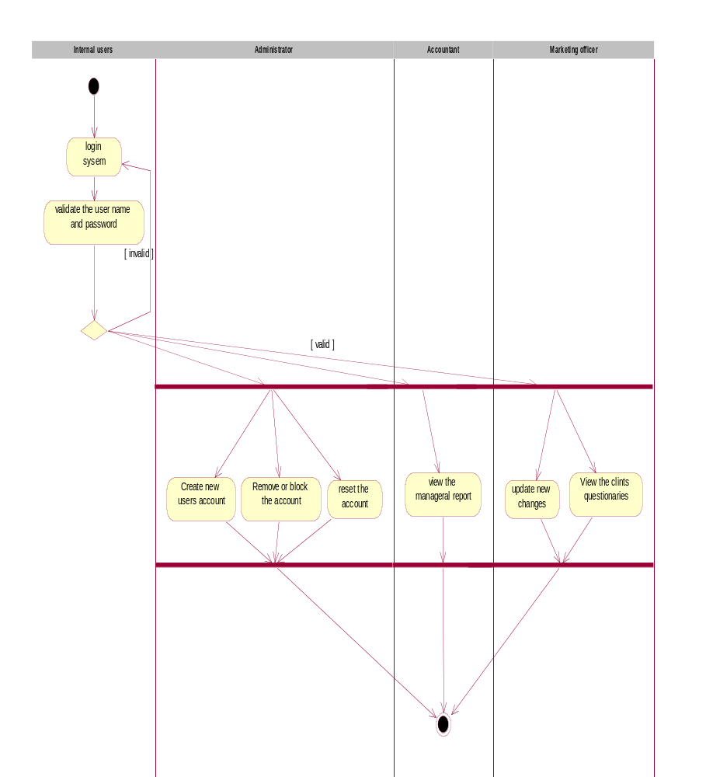
Figure 20: Activity diagram for internal user’s activities.

5. Other Nonfunctional Requirements
Non-functional requirements ^{[2]} are requirements which specify criteria that can be used to judge the operation of a system, rather than specific behaviors.
Our proposed DMS would satisfy the following non functional requirements.

Performance Requirements
Performance requirements constrain the speed of operation of the System.

- The response time for menu changes will be no more than 3 seconds. [Idle -time]
- The response time when a file is accessed will be no more than 5 seconds.
- The time to verify the username and password will be no more than 3 seconds.
- The maximum time to navigate through any link which views a web page with information will be 8 seconds.

Safety Requirements
We consider all the requirements on safety – related the system. We will use simple technique for integrating all data in the system.

Security Requirements
Security requirements ^{[3]} are included in the system to ensure:

- Unauthorised access to the system and its data is not allowed
- The access permissions for system data can only be changed by the system’s administrator
- Ensure the integrity of the system from accidental damage

Software Quality Attributes
Software quality attribute is a non-functional requirement for a software program which is not called up by the customer's contract, but nevertheless is a desirable requirement which enhances the quality of the software program.

5.4.1 Usability
Usability ^{[1]} concerned with specifying the user interface and end-user interactions with the system.
Well structured user manuals, informative error messages and consistent interfaces, by using these features our system will enhance usability.

5.4.2 Maintainability
Maintainability concerned performing a successful repair action within a given time. Our system will be developed based on object oriented theories. So anyone can continue to develop or easily change.

5.4.3 Robustness
The system will not be broken down easily and will not wholly affect by a single application failure.
The system will be either recovered quickly from or held up well under exceptional circumstances.
Persistence of information given to the user and operation visibility to make the choice of actions will be performed visible to the user.
The system would provide meaningful feedback when errors occur and provide context-sensitive user help facilities.

5.4.4 Availability/Reliability

The system will continuously operational for a desirably long length of time.
Since our Student information system consists of many parts in which almost all parts usually need to be present in order for the whole to be operational, much deliberation will be on high availability centers such as backups, failover (failures recovery) processing and data storage and access.
The system would be fault tolerant, in other words system will be able to continue functioning when part of the system fails.
Parts of the system are well-designed and will be thoroughly tested before they are used.

5.5 Business Rules

Business rules that apply to manual aspects of the overall business process that the application supports, which didn't lead to software functionality but nonetheless are rules that affect business operations. They might lead to functionality in the future, though, so need to document the rule.

- Administrator is going handle the internal user accounts in DMS.

- Marketing officer is going to update the DMS according to the current global economy, and using DMS, find the way to attract clients (tourist).

- Accountant is going to analyze the WTL’s Current situation (profit, non profit… etc) through provided managerial reports by DMS.

6. Other Requirements

6.1 Appendix A: Glossary

WTL - Walkers Tours Limited

SRS - Software Requirement Specification
.
DMS - Destination Management System.

PC - Personal Computer.

RAM - Random Access Memory

GB - Giga Byte.

ASP.NET - Application Service Provider.NET.

MS.SQL - Microsoft Structured Query Language

HTML - Hyper Text Markup Language.

I.C - Identification Card

Users’ Manual - A step by step user guide

Computer system -Computer equipment and programs

Database - Information relating to the registered student, logins, selected students for Courses and vacancies

Web - a subnet of internet providing hypertext service

Post conditions - Any criteria that should be satisfy on completion the use case.

Pre conditions - Any criteria that should be satisfy before initiating the use case.

Use case - A sequence of transactions performed by a system that yields as a Meaningful result of values to a particular actor

Client - A person or the organization who requests to develop computer
System

6.2 Appendix B: Class Diagram

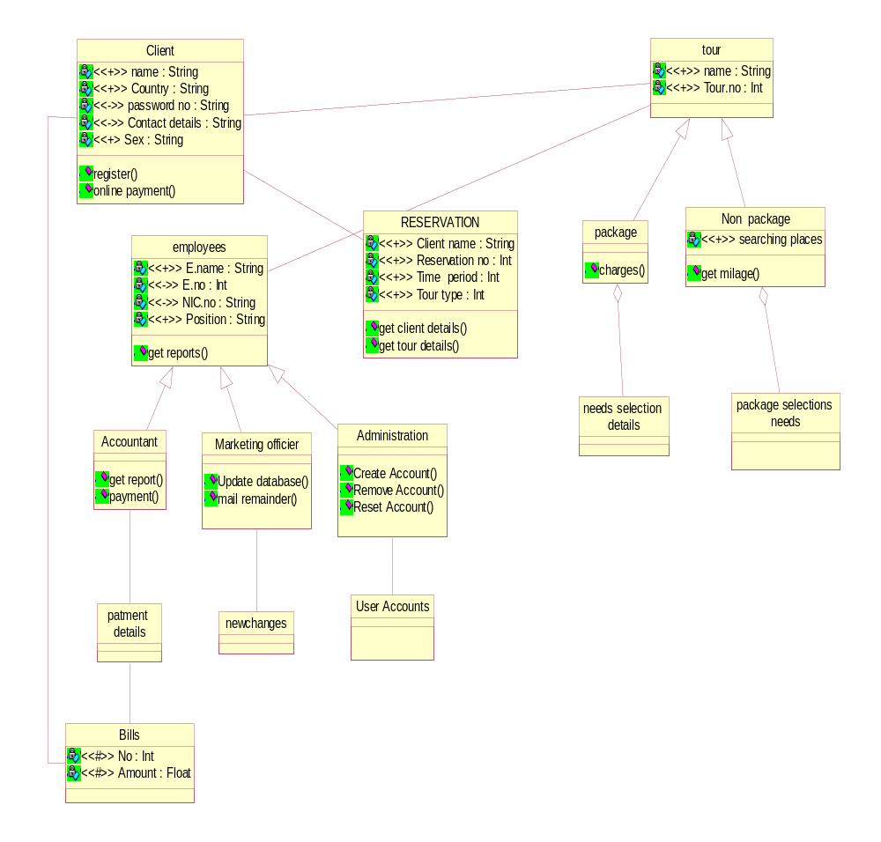

Figure21: Class diagram for Destination management system

6.3 Appendix C: Flow of user interface

Home
Login
About Sri Lanka
Services
Administrator
Marketing Officer
Accountant
Contact Us
Site Map
Add New User
Reset User Profiles
Reset Password

Remove User
Update Database
Mail Upcoming Events
View Comments or Question
Reset Password
Managerial Reports
Reset Password
Sri Lankan Tour Places
Hotels and Foods
Package Wised
Non-Package Wised
Total Expense
Registration
On-line Payment
Select Hotel Type
Select Food Type
Select Vehicle Type
Select Other Services

Figure22: Flow of user interface

